Crown College Nursing Department
Office: 952-446-4482 E-mail: nursing@crown.edu
Application for BSN-Prelicensure Acceptance

Deadline for submission is Friday, February 6, 2026, by 4:00pm CST
Submit application and supplemental documents via Clinician Nexus

First and Last Name Click or tap here to enter text.
Date of Birth: Click or tap to enter a date.
Semester/Year to start junior Nursing classes (“Fall 2026”): Click or tap here to enter text.
Home Address Click or tap here to enter text.
Email: Click or tap here to enter text. Cell: Click or tap here to enter text.
In this application, you are declaring your intent to be considered for acceptance to the Crown College Nursing Department, having met the minimum requirements listed on page 2 of this document. Space may be limited; not all qualified applicants are guaranteed acceptance.

Click or tap here to enter text. Click or tap to enter a date.
Applicant’s Signature Date

NOTE: By signing above, the applicant releases Crown College, its employees, consultants/contractors, and all individuals involved in providing or collecting data, from any responsibility related to perceived/actual harm or damages as a result of this application and verification process. The applicant agrees to waive all rights to artifacts submitted, data collected, and scores assigned for the purposes of establishing priority in the acceptance process. The applicant understands that they may only receive their standing on the waiting list and not any other data such as scores, reviewers' comments, or acceptance priority.

Nursing Application Minimum Requirements
The following are minimum threshold requirements to be considered for acceptance into the Crown College Nursing Department. Space may be limited, however, and not all qualified applicants are guaranteed acceptance.
- Be age 18 or older by the start of the program/starting NUR courses.
- Achieve a cumulative GPA of at least 2.75, pending spring or summer grades. GPA will be calculated based on all current/previous college-level coursework.
- Complete all bolded prerequisite courses with a grade of C+ or higher, pending spring or summer grades, and with no prerequisite course being taken more than twice. All prerequisite coursework must be completed prior to starting any NUR courses. Science prerequisite courses must have been taken within the past five years.
- Be recommended for acceptance to the Nursing Department by one person outside the Nursing Department.
- Disclose any disciplinary concerns that have arisen while a college student at Crown or other academic institutions.
- Provide proof of current certification in Basic Life Support (BLS) for the Health Care Provider through the American Heart Association.
- Obtain a cleared background check from the Minnesota Department of Human Services (DHS) prior to starting clinicals. The process is initiated by the Nursing Department Administrative Assistant.
- Demonstrate a level of personal health consistent with safe nursing practice as determined in a physical examination within the past 12 months. Each student must submit a completed “Crown College Nursing Department Essential Function and Physical Assessment Form” prior to starting clinical experiences.
- Provide one of the following negative TB test results within the past 12 months.
- Single-step Mantoux (TB skin test-TST)
- QuantiFERON-TB Gold Plus test or T-SPOT TB test
- After admission to nursing program, annual TB testing may be required, depending upon clinical placement. A symptoms assessment form may also be required if exposure is suspected.
- Provide documentation for Minnesota Department of Health Recommended Vaccines for Health Care Personnel (https://www.health.state.mn.us/people/immunize/basics/hcpvax.html)
- Hepatitis B series
- MMR – Measles, Mumps, & Rubella
- Varicella – Chickenpox
- Tetanus, diphtheria, and pertussis (Tdap) once and Tdap booster every 10 years
- Influenza – annually
- Comply with current Minnesota Department of Health COVID-19 Recommendations for Health Care Workers and clinical site requirements. COVID-19 vaccination is not required to be accepted in the Nursing Program. Preference for exemption should be disclosed when other required vaccination documentation is provided. Completion of a COVID-19 vaccination exemption form may be required by a clinical site but is not required at the time of application to the program.
- Comply with facility-specific requirements, such as drug and alcohol testing, with negative results.
- Comply with all policies and procedures of the most current Nursing Department Student Handbook and the most recent edition of the Crown College Catalog.

Notification of Decision
The Crown College Nursing Department will send all notifications pertaining to nursing application and acceptance via official Crown College e-mail. Students will be notified of either final acceptance, conditional acceptance, waiting list eligibility, or final non-acceptance by June 30. Final acceptance will be given no later than September 1.

Waiting List Eligibility
The waiting list will be comprised of qualified applicants who were not accepted into the Nursing Department due to seat limitations. The rank on the waiting list will be based on the categories listed below.

Category | Criteria
1 | Students who completed 36 or more credits at Crown College and met the application due date, as well as students who were accepted through Direct Admission to the nursing program
2 | Students who completed 12 to 35.5 credits at Crown College and met the application due date.
3 | Students who completed fewer than 12 credits at Crown College and/or did not meet the application due date.
Students in Category 1 will be considered before students in Category 2, and students in Category 3 will be considered last. Regardless of student category, all Nursing Department acceptance criteria (per the most recent edition of the Nursing Student Handbook) must be met to be accepted into the nursing program.

Non-Acceptance to the Crown College Nursing Department
Any student that is not accepted into the nursing program may reapply for acceptance in any future year.

Paperwork to Submit after Application on Clinician Nexus: After you submit your application to nursing@crown.edu, you will be sent an email from Clinician Nexus to create an account. This account will be used to track documentation and is used by some of our sites for clinical onboarding.

- Recommendation Letter (this can be sent directly from your reference to nursing@crown.edu)
- Copy of American Heart Association (AHA) BLS Card (Classes available at Crown EMTI)
- Immunization Record (Hep B, MMR, Tdap, Varicella)
- Crown College Nursing Department Essential Function and Physical Assessment Form
- TB Result(s)
- MN Department of Health Background Check
- Headshot for badges
- COVID Vaccination Status (this vaccination is not required; we just need to know if you have received it as there is still a site that requires an exemption form be filled out)
- Emergency Contact


Once inside Clinician Nexus
Upload Files to the Document Library:
The document library is where you can keep your documents and apply them to subsequent rotations and School Compliance Steps.
Note: The document library is independently managed by the student and is not accessible to school coordinators.
Uploading files to the Document Library page...
- Click Document Library from the left menu
- Click the teal box at the top of the page and upload files from your computer, or drag them into the box from your desktop
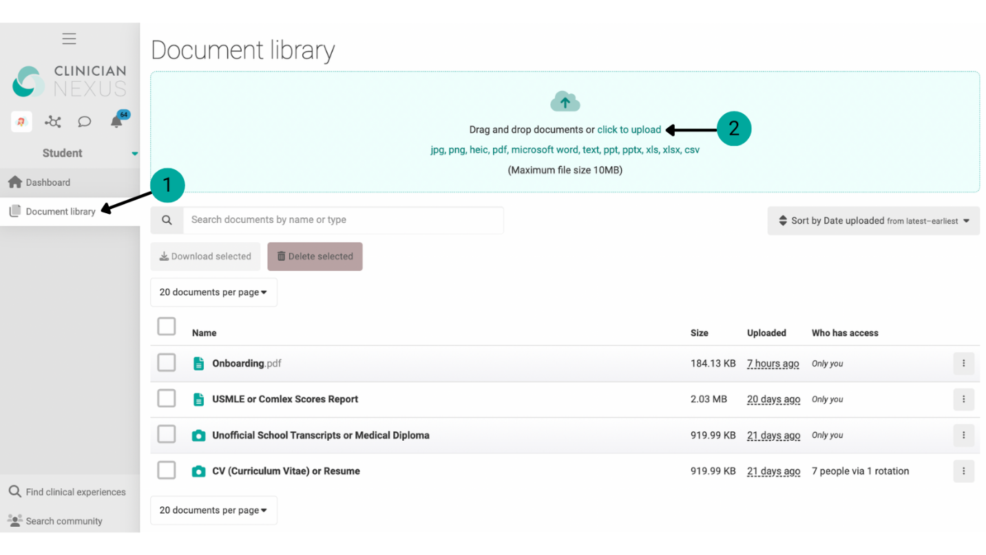
Once your documents are loaded into your Document Library, you will need to complete the School Compliance steps by following the instructions on the next page.
Upload School Compliance Steps Using the Document Library:
- Click My Steps from the left menu
- Click Upload file in the step you wish to complete
- Click Document library and select the document you wish to use complete this step
- Click Upload selected file

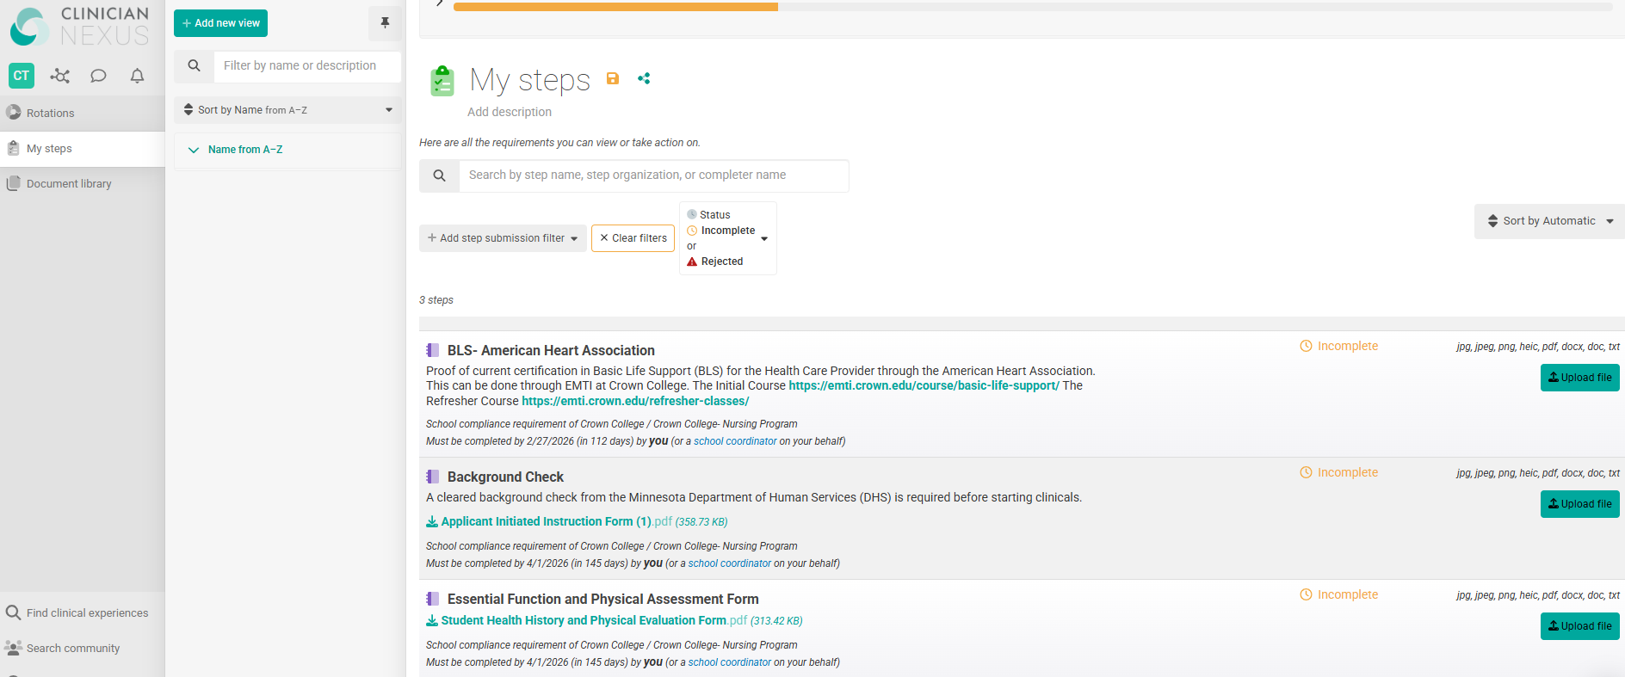
2
10.500.50

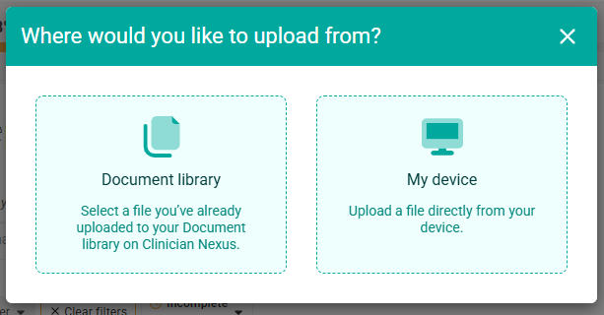
30.500.50
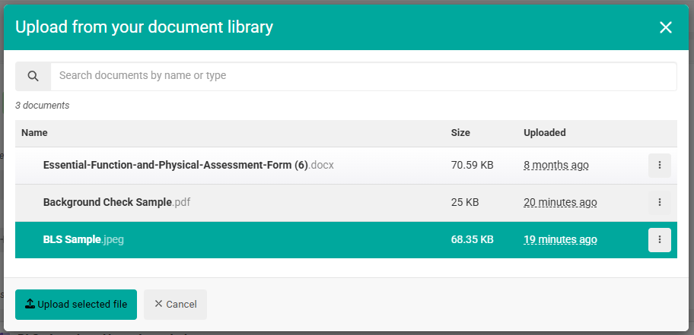
5.500.50
40.500.50

Once the document has been submitted, it will come to the Nursing Department for approval. If your document is rejected, a reason will be provided allowing opportunity for resolution. You will then have to upload a new document based upon the instructions provided.

After all your documents have been submitted and approved, you will be notified by
June 30th
of your acceptance or conditional acceptance into the Nursing Program.

